XI. Microsoft's operating systems

Operating system

An operating system (OS) is system software that manages computer hardware and software resources and provides common services for computer programs. The operating system is a component of the system software in a computer system. Application programs usually require an operating system to function.

For hardware functions such as input and output and memory allocation, the operating system acts as an intermediary between programs and the computer hardware, although the application code is usually executed directly by the hardware and frequently makes system calls to an OS function or is interrupted by it. Operating systems are found on many devices that contain a computer – from cellular phones and video game consoles to web servers and supercomputers.

Examples of popular desktop operating systems include Apple OS X, Linux and its variants, and Microsoft Windows. So-called mobile operating systems include Android and iOS. Other classes of operating systems, such as real-time (RTOS), also exist.

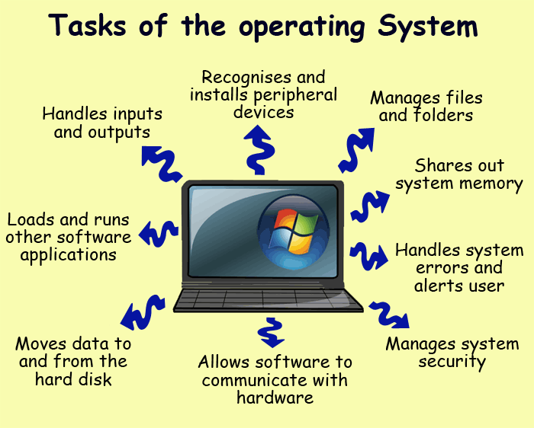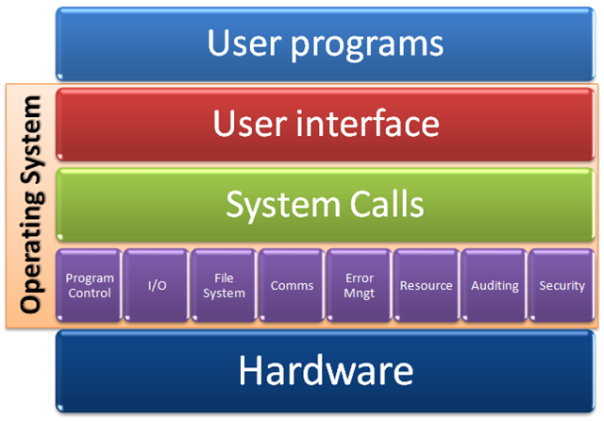

Microsoft Windows

Microsoft Windows (or simply Windows) is a metafamily of graphical operating systems developed, marketed, and sold by Microsoft. It consists of several families of operating systems, each of which cater to a certain sector of the computing industry. Active Windows families include Windows NT, Windows Embedded and Windows Phone; these may encompass subfamilies, e.g. Windows Embedded Compact (Windows CE) or Windows Server. Defunct Windows families include Windows 9x and Windows Mobile.

Microsoft introduced an operating environment named Windows on November 20, 1985, as a graphical operating system shell for MS-DOS in response to the growing interest in graphical user interfaces (GUIs). Microsoft Windows came to dominate the world's personal computer market with over 90% market share, overtaking Mac OS, which had been introduced in 1984. However, since 2012, because of the massive growth of smartphones, Windows sells less than Android, which became the most popular operating system in 2014, when counting all of the computing platforms each operating system runs on; in 2014, the number of Windows devices sold were less than 25% of Android devices sold. However, comparisons across different markets are not fully relevant; and for personal computers, Windows is still the most popular operating system.

As of March 2016, the most recent version of Windows for personal computers, tablets, smartphones and embedded devices is Windows 10. The most recent versions for server computers is Windows Server 2012 R2. A specialized version of Windows runs on the Xbox One game console.

Components

The components of an operating system all exist in order to make the different parts of a computer work together. All software users need to go through the operating system in order to use any of the hardware.

Kernel
With the aid of the firmware and device drivers, the kernel provides the most basic level of control over all of the computer's hardware devices. It manages memory access for programs in the RAM, it determines which programs get access to which hardware resources, it sets up or resets the CPU's operating states for optimal operation at all times, and it organizes the data for long-term non-volatile storage with file systems on such media as disks, tapes, flash memory, etc.

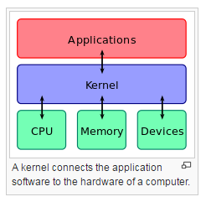

Program execution
The operating system provides an interface between an application program and the computer hardware, so that an application program can interact with the hardware only by obeying rules and procedures programmed into the operating system. The operating system is also a set of services which simplify development and execution of application programs. Executing an application program involves the creation of a process by the operating system kernel which assigns memory space and other resources, establishes a priority for the process in multi-tasking systems, loads program binary code into memory, and initiates execution of the application program which then interacts with the user and with hardware devices.

Interrupts
Interrupts are central to operating systems, as they provide an efficient way for the operating system to interact with and react to its environment. The alternative – having the operating system "watch" the various sources of input for events (polling) that require action – can be found in older systems with very small stacks (50 or 60 bytes) but is unusual in modern systems with large stacks. Interrupt-based programming is directly supported by most modern CPUs. Interrupts provide a computer with a way of automatically saving local register contexts, and running specific code in response to events. Even very basic computers support hardware interrupts, and allow the programmer to specify code which may be run when that event takes place.

Modes
Modern CPUs support multiple modes of operation. CPUs with this capability use at least two modes: protected mode and supervisor mode. The supervisor mode is used by the operating system's kernel for low level tasks that need unrestricted access to hardware, such as controlling how memory is written and erased, and communication with devices like graphics cards. Protected mode, in contrast, is used for almost everything else. Applications operate within protected mode, and can only use hardware by communicating with the kernel, which controls everything in supervisor mode. CPUs might have other modes similar to protected mode as well, such as the virtual modes in order to emulate older processor types, such as 16-bit processors on a 32-bit one, or 32-bit processors on a 64-bit one.

Memory management
Among other things, a multiprogramming operating system kernel must be responsible for managing all system memory which is currently in use by programs. This ensures that a program does not interfere with memory already in use by another program. Since programs time share, each program must have independent access to memory.

Virtual memory
The use of virtual memory addressing (such as paging or segmentation) means that the kernel can choose what memory each program may use at any given time, allowing the operating system to use the same memory locations for multiple tasks.

Multitasking
Multitasking refers to the running of multiple independent computer programs on the same computer; giving the appearance that it is performing the tasks at the same time. Since most computers can do at most one or two things at one time, this is generally done via time-sharing, which means that each program uses a share of the computer's time to execute.

Disk access
Access to data stored on disks is a central feature of all operating systems. Computers store data on disks using files, which are structured in specific ways in order to allow for faster access, higher reliability, and to make better use of the drive's available space. The specific way in which files are stored on a disk is called a file system, and enables files to have names and attributes. It also allows them to be stored in a hierarchy of directories or folders arranged in a directory tree.

File systems
In computing, a file system (or filesystem) is used to control how data is stored and retrieved. Without a file system, information placed in a storage area would be one large body of data with no way to tell where one piece of information stops and the next begins. By separating the data into pieces and giving each piece a name, the information is easily isolated and identified. Taking its name from the way paper-based information systems are named, each group of data is called a "file". The structure and logic rules used to manage the groups of information and their names is called a "file system".

Device drivers
A device driver is a specific type of computer software developed to allow interaction with hardware devices. Typically this constitutes an interface for communicating with the device, through the specific computer bus or communications subsystem that the hardware is connected to, providing commands to and/or receiving data from the device, and on the other end, the requisite interfaces to the operating system and software applications. It is a specialized hardware-dependent computer program which is also operating system specific that enables another program, typically an operating system or applications software package or computer program running under the operating system kernel, to interact transparently with a hardware device, and usually provides the requisite interrupt handling necessary for any necessary asynchronous time-dependent hardware interfacing needs.

Networking
Currently most operating systems support a variety of networking protocols, hardware, and applications for using them. This means that computers running dissimilar operating systems can participate in a common network for sharing resources such as computing, files, printers, and scanners using either wired or wireless connections. Networks can essentially allow a computer's operating system to access the resources of a remote computer to support the same functions as it could if those resources were connected directly to the local computer. This includes everything from simple communication, to using networked file systems or even sharing another computer's graphics or sound hardware. Some network services allow the resources of a computer to be accessed transparently, such as SSH which allows networked users direct access to a computer's command line interface.

Security
A computer being secure depends on a number of technologies working properly. A modern operating system provides access to a number of resources, which are available to software running on the system, and to external devices like networks via the kernel.

User interface
Every computer that is to be operated by an individual requires a user interface. The user interface is usually referred to as a shell and is essential if human interaction is to be supported. The user interface views the directory structure and requests services from the operating system that will acquire data from input hardware devices, such as a keyboard, mouse or credit card reader, and requests operating system services to display prompts, status messages and such on output hardware devices, such as a video monitor or printer. The two most common forms of a user interface have historically been the command-line interface, where computer commands are typed out line-by-line, and the graphical user interface, where a visual environment (most commonly a WIMP) is present.

